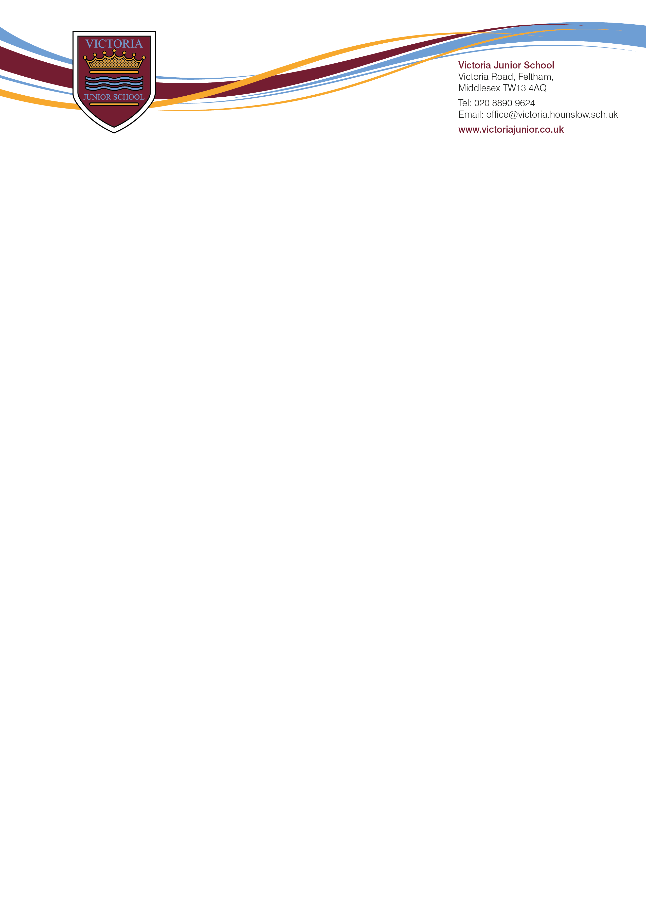

Friday, 8th September 2023

Dear Parents/Carers,

Our Ofsted report from 20th and 21st June 2023 is now ready for publication. Whilst we are satisfied the inspectors saw and acknowledge many of the positive aspects of Victoria Junior School, we are very disappointed with the overall judgement of Requires Improvement.

The report recognises the inclusive and welcoming ethos we have created, and how pupils are happy, show consideration for each other, how pupils are kept safe, feel safe and trust the adults in school. The report also recognises the high expectations we set on pupils’ behaviour and how we have created an ambitious curriculum to meet the needs of our community.

The Ofsted report does explain what they feel the school needs to do better to improve further. Since the inspection, senior leaders have put things in place to improve those areas. We have shown our plans to local authority representatives and to our governors and we are all working together to make these adjustments as swiftly and smoothly as possible.

Like our Chair of Governors writes in the attached letter, we are disappointed with the judgement in the Ofsted report but we are all fully committed to making the changes necessary to make our school even better.

If you wish to discuss the report with me, please contact the school office and I will arrange a meeting with you. Thank you again for your continued support and your understanding that when we work together, we can create great futures for your children.

Yours Sincerely,

David Lee

David Lee

Headteacher